**Code for Iterators:**

const array = [1, 2, 3, 4, 5];

function Iterator(values) {

let nextIndex = 0;

// we will return an object

return {

next: function () {

if (nextIndex < values.length) {

// We will return below object

return {

value: values[nextIndex++],

done: false

}

}

else {

// We will return below object with only done

return {

done: true

}

}

}

}

}

const iterator = Iterator(array);

console.log(iterator.next());

console.log(iterator.next());

console.log(iterator.next());

console.log(iterator.next());

console.log(iterator.next());

console.log(iterator.next());

**Output:**

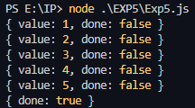

**Code for generators:**

function* genrator() {

yield 1;

yield 2;

yield 3;

}

let c = genrator();

console.log(c.next());

console.log(c.next());

console.log(c.next());

console.log(c.next());

console.log(c.next());

**Output:**

